VISVESVARAYA TECHNOLOGICAL UNIVERSITY
“JnanaSangama”, Belgaum -590014, Karnataka.


LAB REPORT

On

ANALYSIS AND DESIGN OF ALGORITHMS (23CS4PCADA)

Submitted by

Prakash Alagundagi (1BM25CS491)

in partial fulfillment for the award of the degree of
BACHELOR OF ENGINEERING
in
COMPUTER SCIENCE AND ENGINEERING



B.M.S. COLLEGE OF ENGINEERING
(Autonomous Institution under VTU)
BENGALURU-560019
February to June 2026
CERTIFICATE

B. M. S. College of Engineering,
Bull Temple Road, Bangalore 560019
(Affiliated To Visvesvaraya Technological University, Belgaum)
Department of Computer Science and Engineering



This is to certify that the Lab work entitled “ANALYSIS AND DESIGN OF ALGORITHMS” carried out by Prakash Alagundagi (1BM25CS491), who is bonafide student of B. M. S. College of Engineering. It is in partial fulfillment for the award of Bachelor of Engineering in Computer Science and Engineering of the Visvesvaraya Technological University, Belgaum during the year 2025-26. The Lab report has been approved as it satisfies the academic requirements in respect of Analysis and Design of Algorithms Lab - (23CS4PCADA) work prescribed for the said degree.

Dr. Pooja Ahuja S Dr. Kavitha Sooda
Assistant Professor Professor and Head
Department of CSE Department of CSE
BMSCE, Bengaluru BMSCE, Bengaluru

Index Sheet
Sl.  No. | Experiment Title | Page No.
1 | Write program to obtain the Topological ordering of vertices in a given digraph.
2 | Implement Johnson Trotter algorithm to generate permutations.
3 | Sort a given set of N integer elements using Merge Sort technique and compute its time taken. Run the program for different values of N and record the time taken to sort.
4 | Sort a given set of N integer elements using Quick Sort technique and compute its time taken.
5 | Sort a given set of N integer elements using Heap Sort technique and compute its time taken.
6 | Implement 0/1 Knapsack problem using dynamic programming. (5 Marks)
7 | Implement All Pair Shortest paths problem using Floyd’s algorithm.
8 | - Find Minimum Cost Spanning Tree of a given undirected graph using Prim’s algorithm.  - Find Minimum Cost Spanning Tree of a given undirected graph using Kruskal’s algorithm.
9 | Implement Fractional Knapsack using Greedy technique.
10 | From a given vertex in a weighted connected graph, find shortest paths to other vertices using Dijkstra’s algorithm.
11 | Implement “N-Queens Problem” using Backtracking.

Course outcomes:
CO1 | Analyze time complexity of algorithms using asymptotic notations.
CO2 | Apply various algorithm design techniques for the given problem.
CO3 | Evaluate the appropriate algorithm/design technique for solving a given problem.
CO4 | Conduct practical experiments by applying appropriate algorithm design technique to solve problems.

Lab program 1:
Complete program in C

Screenshot of the output to be included for all the cases.

For all sorting programs, graph (plotted in Excel) to be attached and shown for large values of ‘n’ how time increases.

NOTE: SIMILARLY INCLUDE FOR ALL THE LAB PROGRAMS (ALL 11). LEETCODE PROGRAMS ALSO TO BE INCLUDED. Include the Leetcode Programs which you have executed along with the respective lab program.

ENSURE THAT EACH LAB PROGRAM STARTS IN A NEW PAGE ONLY.

LEETCODE 1: 225. Implement Stack using Queues
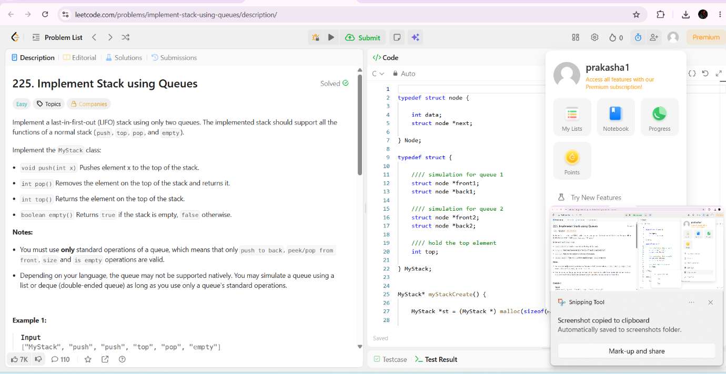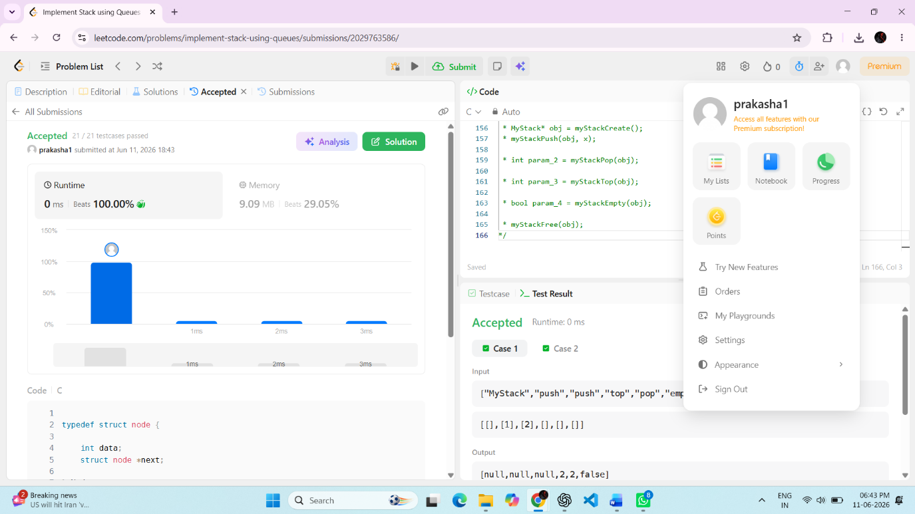

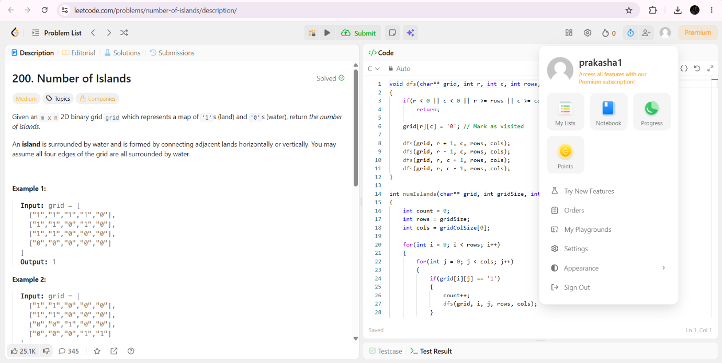
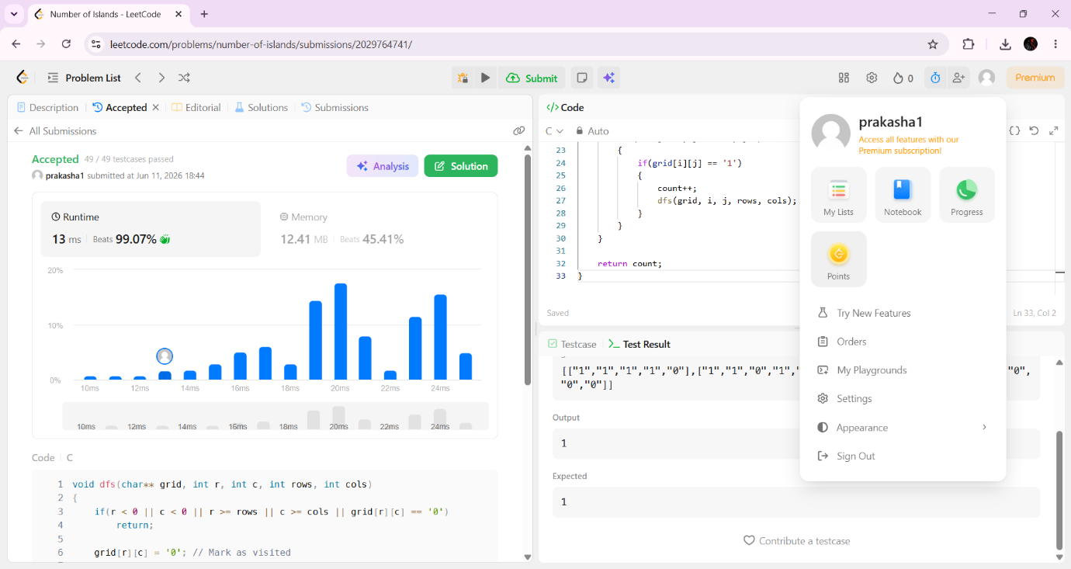

LEETCODE 3: 102. Binary Tree Level Order Traversal
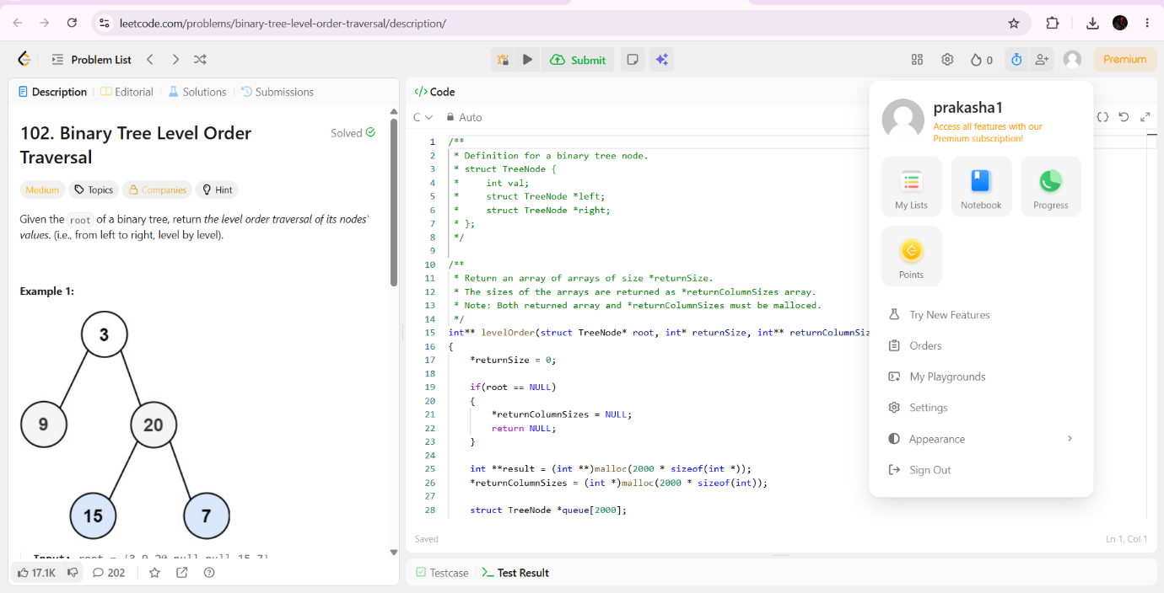

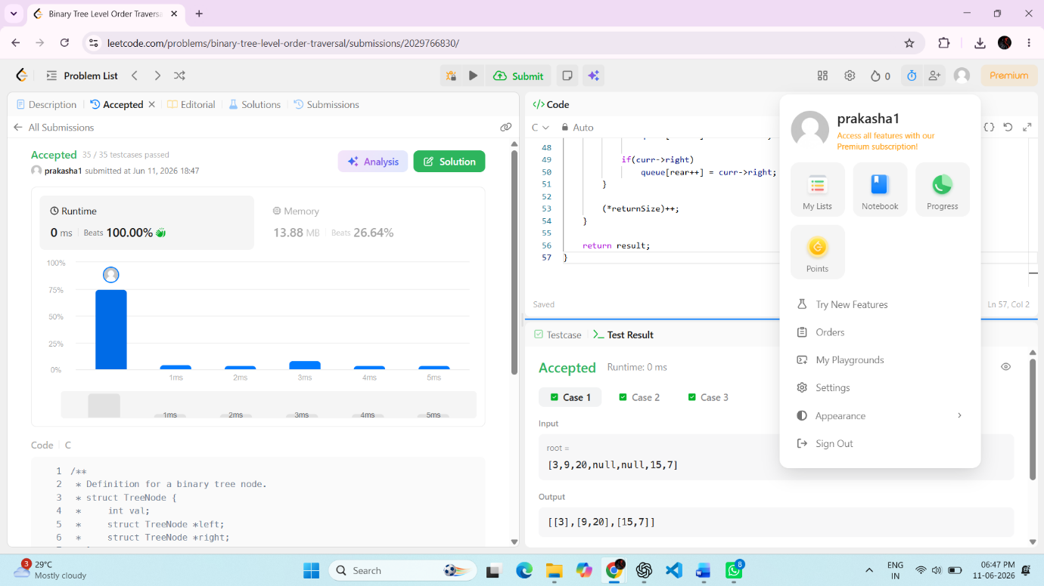

Lab program 1:
Write program to obtain the Topological ordering of vertices in a given digraph.

SOURCE CODE
#include <stdio.h>
#include <stdlib.h>
#define MAX 100

int adj[MAX][MAX];
int indegree[MAX];
int queue[MAX];
int n;

void topologicalSort() {
int front = 0, rear = -1;
int count = 0;
for (int i = 0; i < n; i++)
indegree[i] = 0;

for (int i = 0; i < n; i++) {
for (int j = 0; j < n; j++) {
if (adj[i][j] == 1)
indegree[j]++;
}
}
for (int i = 0; i < n; i++) {
if (indegree[i] == 0)
queue[++rear] = i;
}
printf("\nTopological Order: ");

while (front <= rear) {
int node = queue[front++];
printf("%d ", node);
count++;
for (int i = 0; i < n; i++) {
if (adj[node][i] == 1) {
indegree[i]--;
if (indegree[i] == 0)
queue[++rear] = i;
}
}
}

if (count != n)
printf("\nGraph has a cycle! No topological ordering possible.\n");
}
int main() {
printf("\nEnter number of vertices: ");
scanf("%d", &n);

printf("\nEnter adjacency matrix:\n");
for (int i = 0; i < n; i++) {
for (int j = 0; j < n; j++)
scanf("%d", &adj[i][j]);
}

topologicalSort();
return 0;
}

OUTPUT

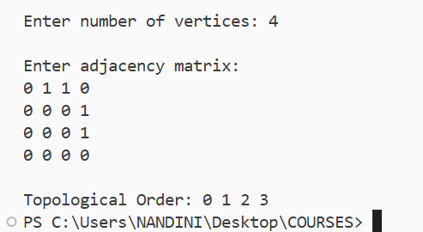

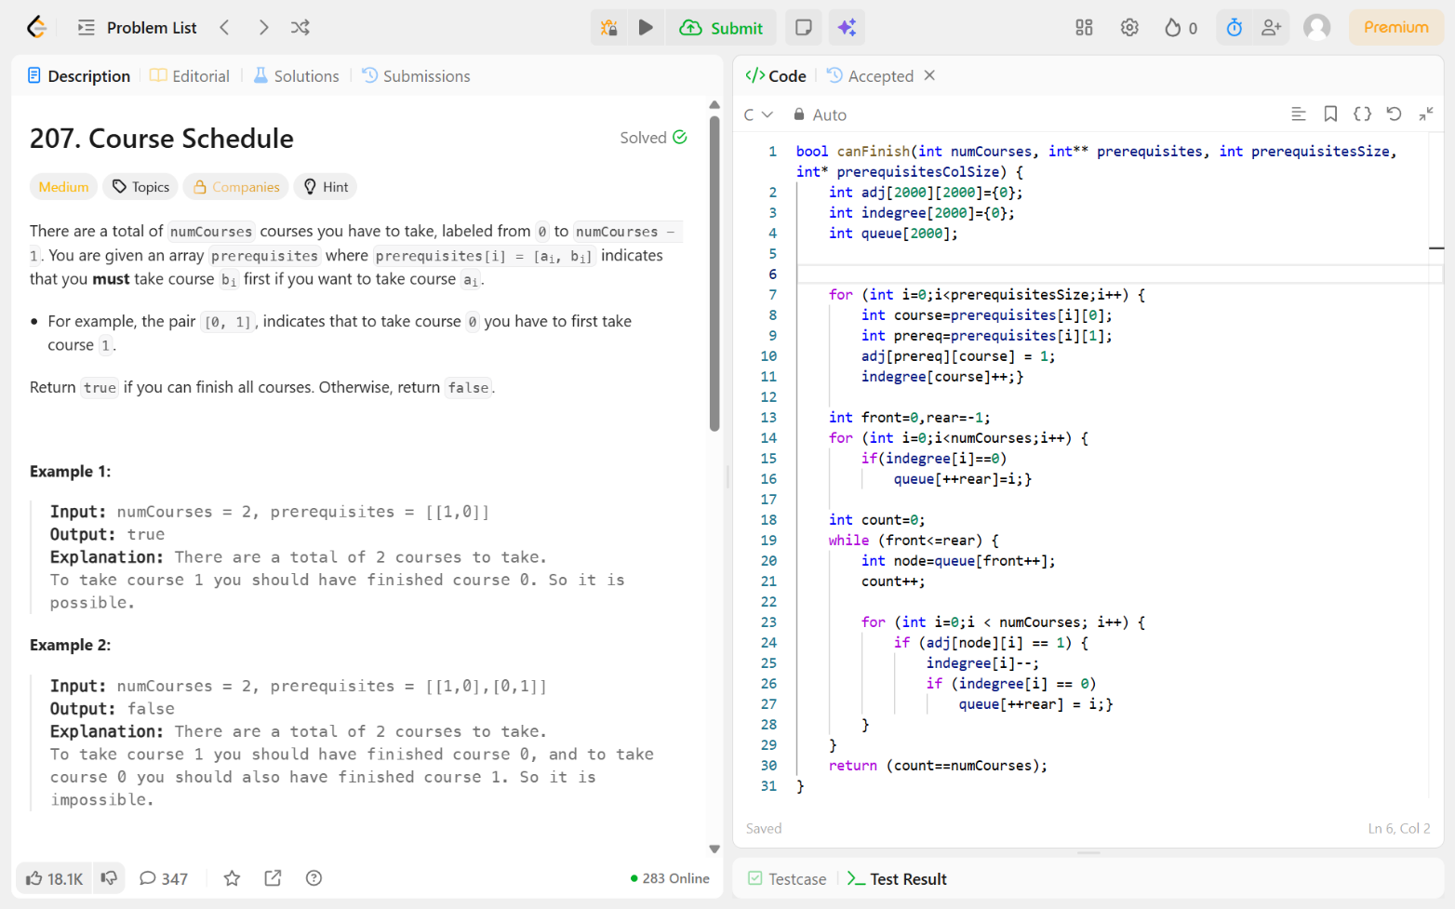
Leetcode Problem 207- Course schedule

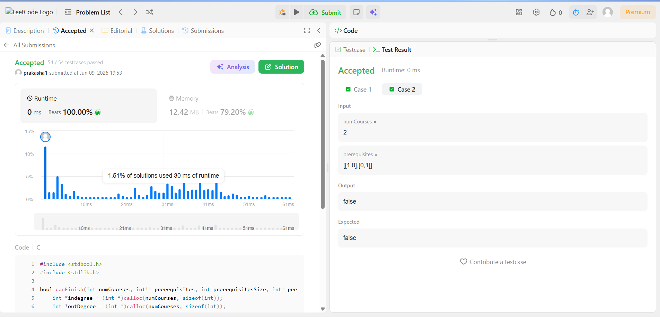

Lab program 2:
Implement Johnson Trotter algorithm to generate permutations.

SOURCE CODE
#include <stdio.h>
int a[10], dir[10];

void print(int n){
for (int i=0;i<n; i++)
printf("%d ", a[i]);
printf("\n");
}

int mobile(int n){
int m=0,pos=-1;

for (int i=0; i<n; i++){
int j=i+dir[i];
if (j >= 0 && j < n && a[i] > a[j] && a[i] > m) {
m=a[i];
pos=i;
}
}
return pos;
}

int main(){
int n;
printf("\nEnter number: ");
scanf("%d", &n);

for (int i=0;i<n;i++) {
a[i]=i+1;
dir[i] = -1;
}

print(n);

while (1) {
int i = mobile(n);
if (i == -1) break;
int j = i + dir[i];
int t = a[i]; a[i] = a[j]; a[j] = t;
t = dir[i]; dir[i] = dir[j]; dir[j] = t;

for (int k = 0; k < n; k++)
if (a[k] > a[j]) dir[k] *= -1;

print(n);
}

return 0;
}

OUTPUT

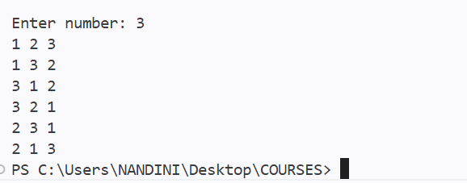

Lab program 3:
Sort a given set of N integer elements using Merge Sort technique and compute its time taken. Run the program for different values of N and record the time taken to sort.

SOURCE CODE
#include <stdio.h>
#include <stdlib.h>
#include <time.h>

int a[5000000],b[5000000];

void merge(int a[],int low,int mid,int high){

int i=low,j=mid+1,k=low;

while(i<=mid && j<=high){
if(a[i]<a[j])
b[k]=a[i++];
else
b[k]=a[j++];
k++;
}
while(i<=mid){
b[k++]=a[i++];
}
while(j<=high){
b[k++]=a[j++];
}
for(int x=low;x<=high;x++)
a[x]=b[x];
}

void merge_sort(int a[],int low,int high){
if(low<high){
int mid=(low+high)/2;
merge_sort(a,low,mid);
merge_sort(a,mid+1,high);
merge(a,low,mid,high);
}
}

int main(){
int n;
printf("\nEnter number of elements: ");
scanf("%d",&n);
printf("\nEntering the elements...");
for(int i=0;i<n;i++){
a[i]=rand()%1000;
printf("%d ",a[i]);
}
clock_t start_time=clock();
merge_sort(a,0,n-1);
clock_t end_time=clock();
printf("\nAfter sorting: ");
for(int i=0;i<n;i++)
printf("%d ",a[i]);
float total_time=(float)(end_time-start_time)/CLOCKS_PER_SEC*1000;
printf("\nTime taken is: %.2f",total_time);
return 0;
}

OUTPUT

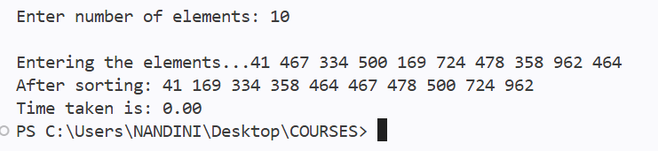

Time taken for each N

N | Time taken
10 | 0.0
50 | 0.0
100 | 0.0
500 | 0.0
1000 | 0.0
5000 | 1.0
10000 | 2.0
50000 | 8.0
100000 | 18.0
500000 | 88.0
1000000 | 266.0

Graph:

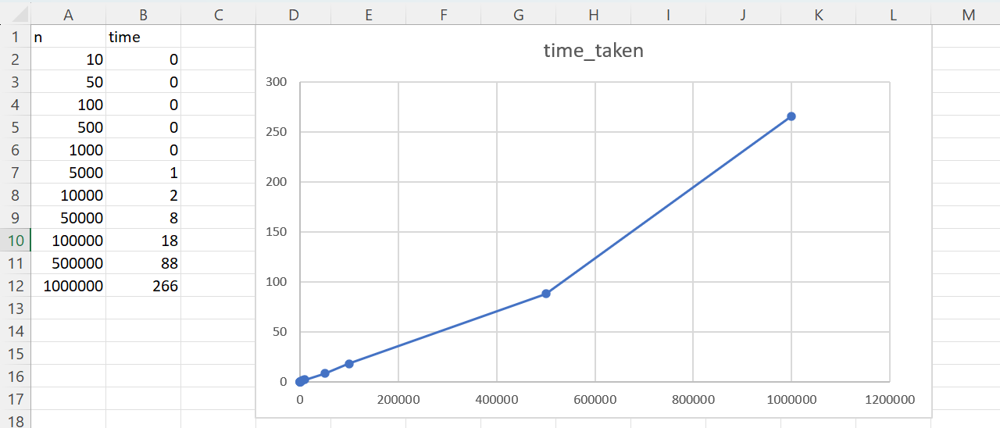

Lab program 4:
Sort a given set of N integer elements using Quick Sort technique and compute its time taken.

SOURCE CODE
#include <stdio.h>
#include <stdlib.h>
#include <time.h>
int a[5000000];

void swap(int *a,int *b){
int temp=*a;
*a=*b;
*b=temp;
}

int partition(int a[],int low,int high){

int pivot=a[low];
int i=low+1;
int j=high;

while(i<=j){
while(i<=high && pivot>=a[i])
i++;
while(j>=low && pivot<a[j])
j--;
if(i<j)
swap(&a[i],&a[j]);
}
swap(&a[low],&a[j]);
return j;
}

void quick_sort(int a[],int low,int high){
if(low<high){
int j=partition(a,low,high);
quick_sort(a,low,j-1);
quick_sort(a,j+1,high);
}
}

int main(){

int n;
printf("\nEnter number of elements: ");
scanf("%d",&n);

printf("\nEntering elements...");
for(int i=0;i<n;i++){
a[i]=rand()%1000;
printf("%d ",a[i]);
}

clock_t start=clock();
quick_sort(a,0,n-1);
clock_t end=clock();

printf("\nAfter sorting....");
for(int i=0;i<n;i++)
printf("%d ",a[i]);

float time_taken=((float)(end-start))/CLOCKS_PER_SEC*1000;
printf("\nTime taken: %.2f",time_taken);

return 0;
}

OUTPUT

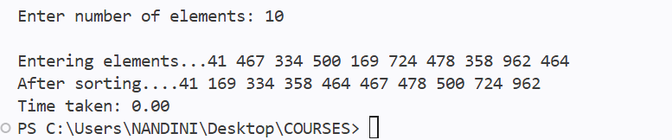

Time taken for each N

N | Time taken
10 | 0.0
50 | 0.0
100 | 0.0
500 | 0.0
1000 | 0.0
5000 | 0.0
10000 | 2.0
50000 | 2.0
100000 | 12.0
500000 | 166.0
1000000 | 450.0

Graph:

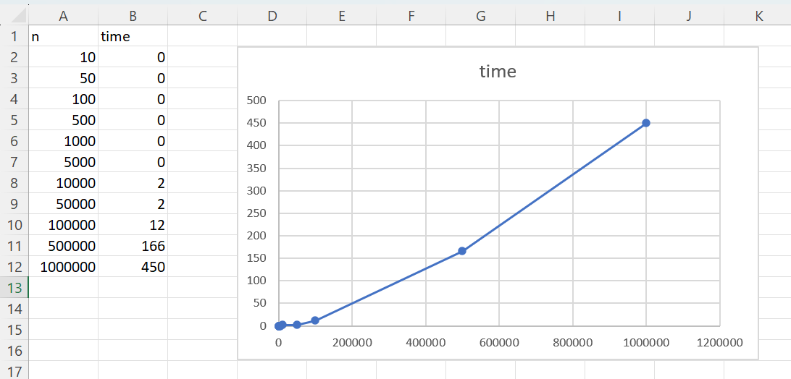

Lab program 5:
Sort a given set of N integer elements using Heap Sort technique and compute its time taken.

SOURCE CODE
#include <stdio.h>
#include <stdlib.h>
#include <time.h>

int a[5000000];

void heapify(int a[],int i,int n){
int largest=i;
int left=2*i+1;
int right=2*i+2;

if(left<n && a[left]>a[largest])
largest=left;
if(right<n && a[right]>a[largest])
largest=right;
if(largest!=i){
int temp=a[i];
a[i]=a[largest];
a[largest]=temp;
heapify(a,largest,n);
}
}

void heap_sort(int a[],int n){
for(int i=(n/2)-1;i>=0;i--)
heapify(a,i,n);
for(int i=n-1;i>0;i--){
int temp=a[0];
a[0]=a[i];
a[i]=temp;
heapify(a,0,i);
}
}

void print(int a[],int n){
for(int i=0;i<n;i++)
printf("%d ",a[i]);
printf("\n");
}

int main(){
int n;
printf("\nEnter number of elements: ");
scanf("%d",&n);
printf("\nEntering elements...");
for(int i=0;i<n;i++){
a[i]=rand()%1000;
}
print(a,n);
clock_t start=clock();
heap_sort(a,n);
clock_t end=clock();
printf("\nAfter sorting....");
print(a,n);
float time_taken=((float)(end-start))/CLOCKS_PER_SEC*1000;
printf("\nTime taken: %.2f",time_taken);
return 0;
}

OUTPUT

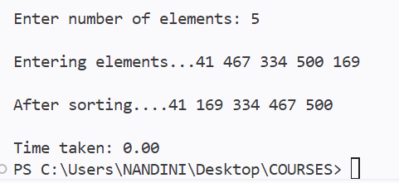

Time taken for each N

N | Time taken
5 | 0
10 | 0
50 | 0
500 | 0
1000 | 0
5000 | 0
10000 | 2
50000 | 4
100000 | 24
500000 | 227
5 | 0

Graph:

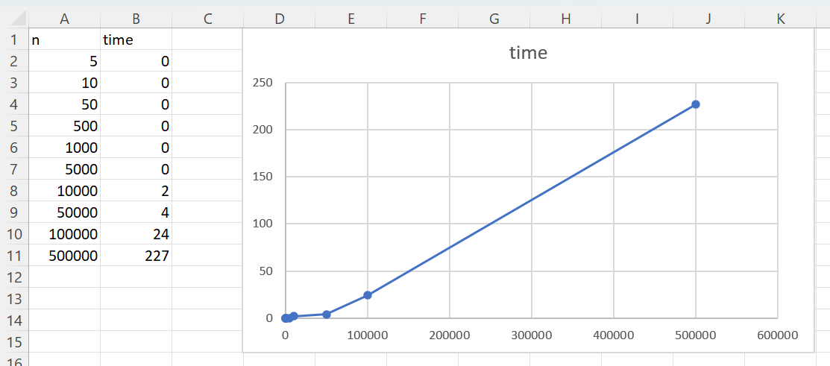

Lab program 6:
Implement 0/1 Knapsack problem using dynamic programming.

SOURCE CODE
#include <stdio.h>

int p[50],w[50],n,m;

void inputs(){
printf("\nEnter number of items: ");
scanf("%d",&n);
printf("\nEnter capacity: ");
scanf("%d",&m);

printf("\nEnter weights: ");
for(int i=1;i<=n;i++)
scanf("%d",&w[i]);
printf("\nEnter profits: ");
for(int i=1;i<=n;i++)
scanf("%d",&p[i]);
}

int max(int a,int b){
return (a>b)?a:b;
}

int knapsack(){
int v[n+1][m+1];
for(int i=0;i<=n;i++){
for(int j=0;j<=m;j++){
if(i==0||j==0)
v[i][j]=0;
else if(w[i]>j)
v[i][j]=v[i-1][j];
else
v[i][j]=max(v[i-1][j],(v[i-1][j-w[i]])+p[i]);
}
}
printf("\nOptimal Profit: %d",v[n][m]);
}

int main(){
inputs();
knapsack();
return 0;
}

OUTPUT

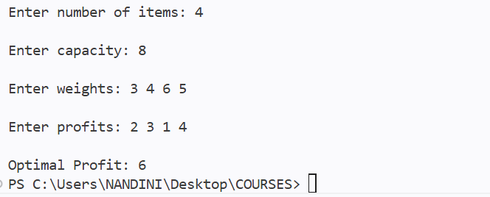

LEETCODE:- ONE AND ZEROS

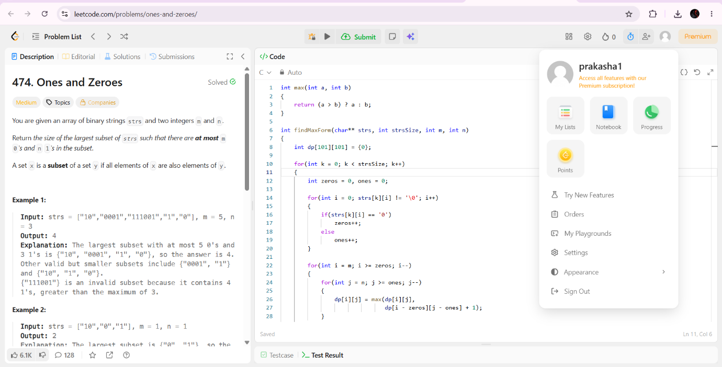

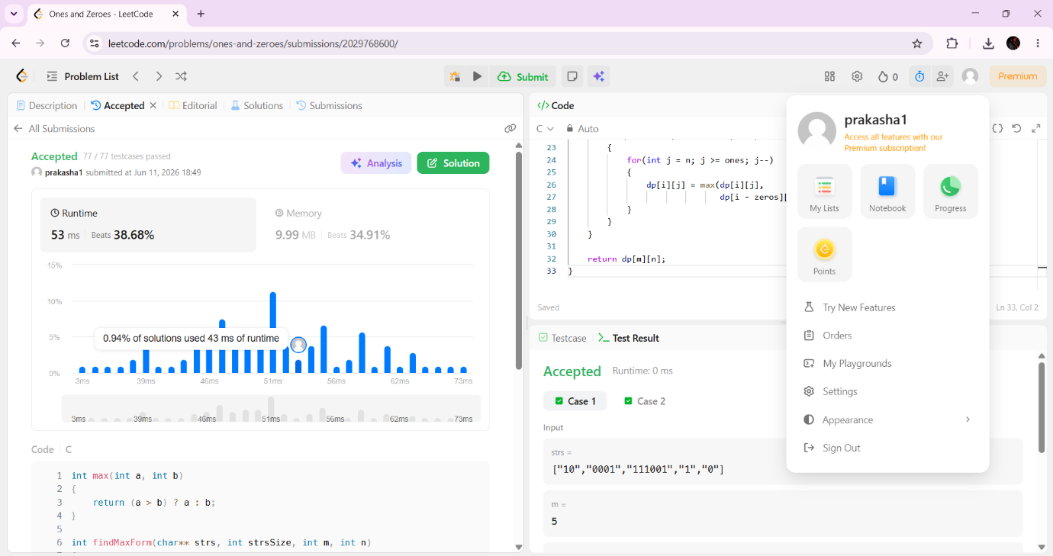

Lab program 7:
Implement All Pair Shortest paths problem using Floyd’s algorithm.

SOURCE CODE
#include <stdio.h>
#include <stdlib.h>
#include <time.h>
#define INF 99999

void floyd(int n,int R[n][n]){
for(int k=0;k<n;k++){
for(int i=0;i<n;i++){
for(int j=0;j<n;j++){
if(R[i][j]>(R[i][k]+R[k][j]))
R[i][j]=R[i][k]+R[k][j];
}
}
}
}

int main(){
int n;
printf("\nEnter number of vertices: ");
scanf("%d",&n);
int R[n][n];
printf("\nEnter adjacency matrix:\n");
for(int i=0;i<n;i++){
for(int j=0;j<n;j++)
scanf("%d",&R[i][j]);
}
floyd(n,R);
printf("\nShortest path:\n");
for(int i=0;i<n;i++){
for(int j=0;j<n;j++){
if(R[i][j]==INF)
printf("INF ");
else
printf("%d ",R[i][j]);
}
printf("\n");
}
return 0;
}

OUTPUT

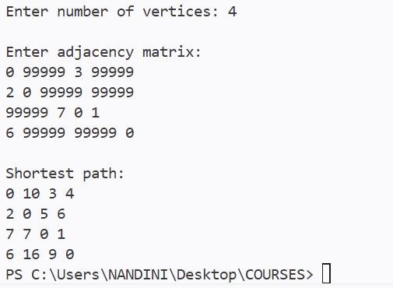

LEETCODE: 1334. Find the City With the Smallest Number of Neighbors at a Threshold Distance

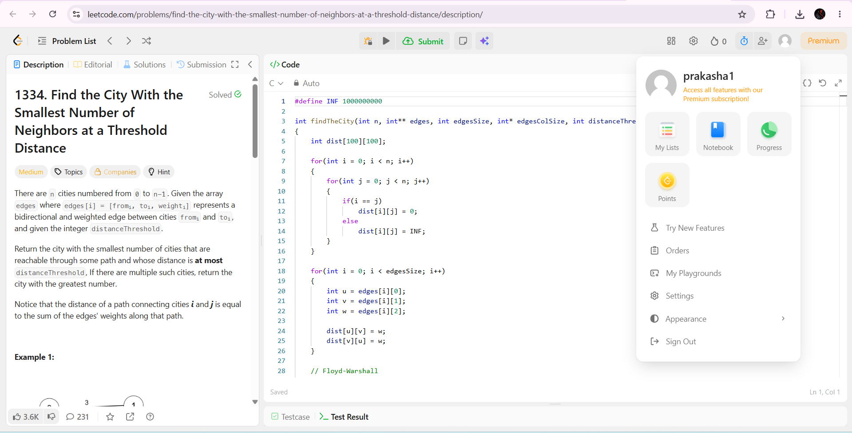

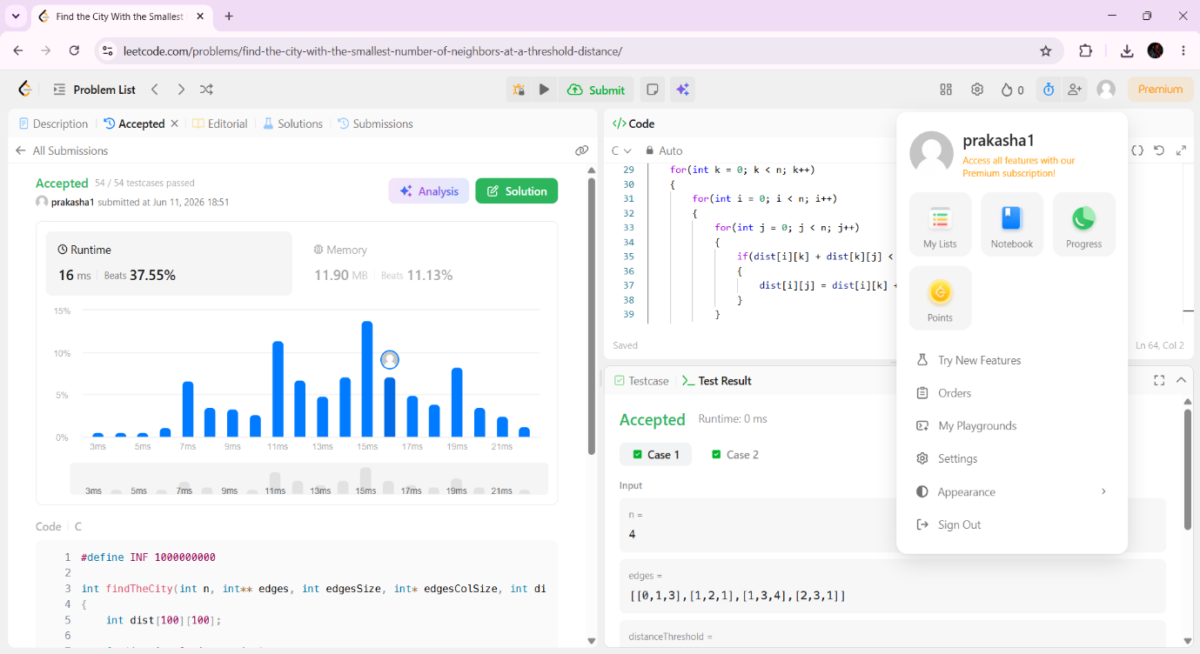

Lab program 8:
- Find Minimum Cost Spanning Tree of a given undirected graph using Prim’s algorithm.

SOURCE CODE
#include <stdio.h>

void prims(int n,int graph[n][n]){

int visited[n];
for(int i=0;i<n;i++)
visited[i]=0;
int edges=0;
visited[0]=1;
int cost=0;
printf("\nEdge\tWeight\n");

while(edges<n-1){

int min=100,x=-1,y=-1;
for(int i=0;i<n;i++){
if(visited[i]==1){
for(int j=0;j<n;j++){
if(visited[j]==0 && graph[i][j]!=0){
if(graph[i][j]<min){
min=graph[i][j];
x=i;
y=j;
}
}
}
}
}

printf("%d - %d\t%d\n",x,y,graph[x][y]);
cost+=graph[x][y];
visited[y]=1;
edges++;
}
printf("\nMinimum Cost %d\n",cost);
}

int main(){
int n;
printf("\nEnter number of vertices: ");
scanf("%d",&n);
int graph[n][n];
printf("\nEnter the adjacency matrix:\n");
for(int i=0;i<n;i++){
for(int j=0;j<n;j++){
scanf("%d",&graph[i][j]);
}
}
prims(n,graph);
return 0;
}

OUTPUT

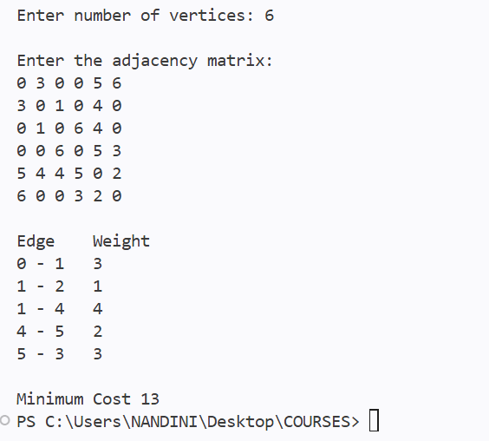

Lab program 8:
- Find Minimum Cost Spanning Tree of a given undirected graph using Kruskal’s algorithm.
SOURCE CODE
#include <stdio.h>

struct Edge{
int u,v,w;
}e[10],temp;

int parent[10];

int find(int x){
while(parent[x]!=x)
x=parent[x];
return x;
}

int main(){

int n,m,cost=0;

printf("\nEnter number of Vertices and Edges: ");
scanf("%d%d",&n,&m);

printf("Enter vertex u v and weight w:\n");

for(int i=0;i<m;i++)
scanf("%d%d%d",&e[i].u,&e[i].v,&e[i].w);

for(int i=0;i<m-1;i++)
for(int j=0;j<m-i-1;j++)
if(e[j].w > e[j+1].w){
temp=e[j];
e[j]=e[j+1];
e[j+1]=temp;
}

for(int i=0;i<n;i++)
parent[i]=i;

printf("\nMST:\n");

for(int i=0,edges=0;i<m && edges<n-1;i++){

int u=find(e[i].u);
int v=find(e[i].v);

if(u!=v){

printf("%d %d %d\n",e[i].u,e[i].v,e[i].w);

cost+=e[i].w;
edges++;

parent[u]=v;
}
}

printf("\nCost = %d",cost);

return 0;
}

OUTPUT

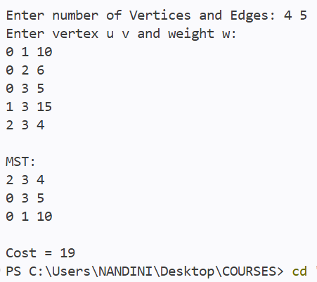

Lab program 9:
Implement Fractional Knapsack using Greedy technique.

SOURCE CODE
#include <stdio.h>

int main(){
int n,rem_weight;
float total_profit=0;

printf("\nEnter number of item: ");
scanf("%d",&n);

int obj[n],p[n],w[n];

printf("\nEnter objects: ");
for(int i=0;i<n;i++)
scanf("%d",&obj[i]);

printf("\nEnter profits: ");
for(int i=0;i<n;i++)
scanf("%d",&p[i]);

printf("\nEnter weights: ");
for(int i=0;i<n;i++)
scanf("%d",&w[i]);

printf("\nEnter remaining weight: ");
scanf("%d",&rem_weight);

float pw[n];
for(int i=0;i<n;i++)
pw[i]=(float)p[i]/w[i];

for(int i=0;i<n;i++){
for(int j=i+1;j<n;j++){
if(pw[i]<pw[j]){
float temp=pw[i];pw[i]=pw[j];pw[j]=temp;
temp=obj[i];obj[i]=obj[j];obj[j]=temp;
temp=p[i];p[i]=p[j];p[j]=temp;
temp=w[i];w[i]=w[j];w[j]=temp;
}
}
}

for(int k=0;k<n;k++){
if((rem_weight-w[k]) >= 0){
rem_weight-=w[k];
total_profit+=p[k];
}
else{
total_profit+=((float)rem_weight/w[k])*p[k];
break;
}
}
printf("\n\nFractional Knapsack:");
printf("\nObject\tProfit\tWeight");
for(int i=0;i<n;i++)
printf("\n%d\t%d\t%d\t\n",obj[i],p[i],w[i]);
printf("\n\nTotal Profit is: %f\n",total_profit);
return 0;
}

OUTPUT

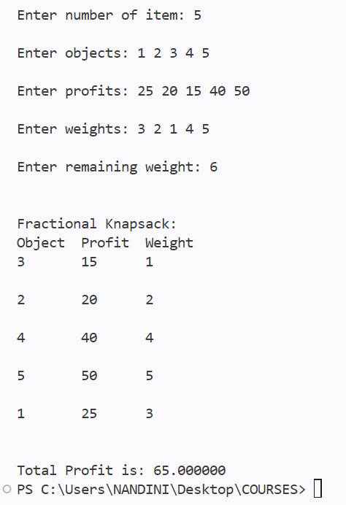

Lab program 10:
From a given vertex in a weighted connected graph, find shortest paths to other vertices using Dijkstra’s algorithm.
SOURCE CODE
#include <stdio.h>
#define INF 99999

int main(){

int n,src;

printf("Enter number of vertices: ");
scanf("%d",&n);

int cost[n][n],dist[n],vis[n];

printf("Enter adjacency matrix:\n");

for(int i=0;i<n;i++)
for(int j=0;j<n;j++)
scanf("%d",&cost[i][j]);

printf("Enter source vertex: ");
scanf("%d",&src);

for(int i=0;i<n;i++){
dist[i]=cost[src][i];
vis[i]=0;
}

dist[src]=0;
vis[src]=1;

for(int i=1;i<n;i++){

int min=INF,u=-1;

for(int j=0;j<n;j++)
if(!vis[j] && dist[j]<min){
min=dist[j];
u=j;
}

vis[u]=1;

for(int v=0;v<n;v++)
if(!vis[v] && dist[u]+cost[u][v]<dist[v])
dist[v]=dist[u]+cost[u][v];
}

printf("\nShortest Distances:\n");

for(int i=0;i<n;i++)
printf("%d -> %d = %d\n",src,i,dist[i]);

return 0;
}

OUTPUT

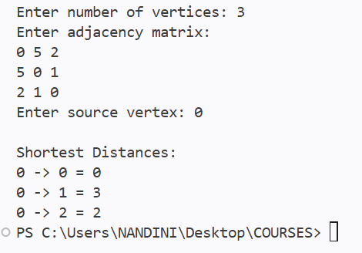

Lab program 10:
Implement “N-Queens Problem” using Backtracking.

SOURCE CODE
#include <stdio.h>
#include <stdlib.h>
int x[20], n;

int place(int k, int i){
for(int j=1; j<k; j++){
if(x[j]==i || abs(x[j]-i)==abs(j-k))
return 0;
}
return 1;
}

void nqueen(int k){
for(int i=1; i<=n; i++){
if(place(k,i)){
x[k]=i;
if(k==n){
printf("\nSolution:\n");
for(int r=1; r<=n; r++){
for(int c=1; c<=n; c++){

if(x[r]==c)
printf("Q ");
else
printf(". ");
}
printf("\n");
}
printf("\n");
}
else
nqueen(k+1);
}
}
}

int main(){

printf("Enter value of n: ");
scanf("%d",&n);

nqueen(1);

return 0;
}

OUTPUT

